Start coding or ge nerate with AI.

import pandas as pd

import seaborn as sns

import matplotlib.pyplot as plt

data = pd.read_csv('/content/News.csv',index_col=0) data.head()

 title text subject date class

1. Donald Trump Sends Out Embarrassing New Year’...
2. Drunk Bragging Trump Staffer Started Russian ...
3. Sheriff David Clarke Becomes An

Internet Joke...

1. Trump Is So Obsessed He Even Has

Obama’s Name...

1. Pope Francis Just Called Out Donald Trump Dur...

Donald Trump just couldn t wish

all Americans ...

House Intelligence Committee Chairman Devin Nu...

On Friday, it was revealed that

former Milwauk...

On Christmas day, Donald Trump

announced that ...

Pope Francis used his annual Christmas Day mes...

News December 31,

2017

0

News December 31,

0

2017

News December 30,

0

2017

News December 29,

0

2017

News December 25,

0

2017

Next steps:

Generate code with data

 View recommended plots

data.shape

(44919, 5)

data = data.drop(["title", "subject","date"], axis = 1)

data.isnull().sum()

text 0

class 0

dtype: int64

# Shuffling

data = data.sample(frac=1)

data.reset_index(inplace=True)

data.drop(["index"], axis=1, inplace=True)

sns.countplot(data=data,

x='class',

order=data['class'].value_counts().index)

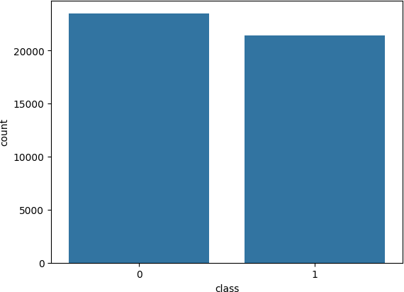<Axes: xlabel='class', ylabel='count'>

from tqdm import tqdm import re

import nltk

nltk.download('punkt')

nltk.download('stopwords')

from nltk.corpus import stopwords

from nltk.tokenize import word_tokenize

from nltk.stem.porter import PorterStemmer from wordcloud import WordCloud

[nltk_data] Downloading package punkt to /root/nltk_data... [nltk_data] Unzipping tokenizers/punkt.zip.

[nltk_data] Downloading package stopwords to /root/nltk_data... [nltk_data] Unzipping corpora/stopwords.zip.

def preprocess_text(text_data): preprocessed_text = []

for sentence in tqdm(text_data):

sentence = re.sub(r'[^\w\s]', '', sentence)

preprocessed_text.append(' '.join(token.lower()

for token in str(sentence).split()

if token not in stopwords.words('english')))

return preprocessed_text

preprocessed_review = preprocess_text(data['text'].values) data['text'] = preprocessed_review

100%|██████████| 44919/44919 [35:50<00:00, 20.89it/s]

# Real

consolidated = ' '.join(

word for word in data['text'][data['class'] == 1].astype(str)) wordCloud = WordCloud(width=1600,

height=800,

random_state=21, max_font_size=110,

collocations=False) plt.figure(figsize=(15, 10))

plt.imshow(wordCloud.generate(consolidated), interpolation='bilinear') plt.axis('off')

plt.show()

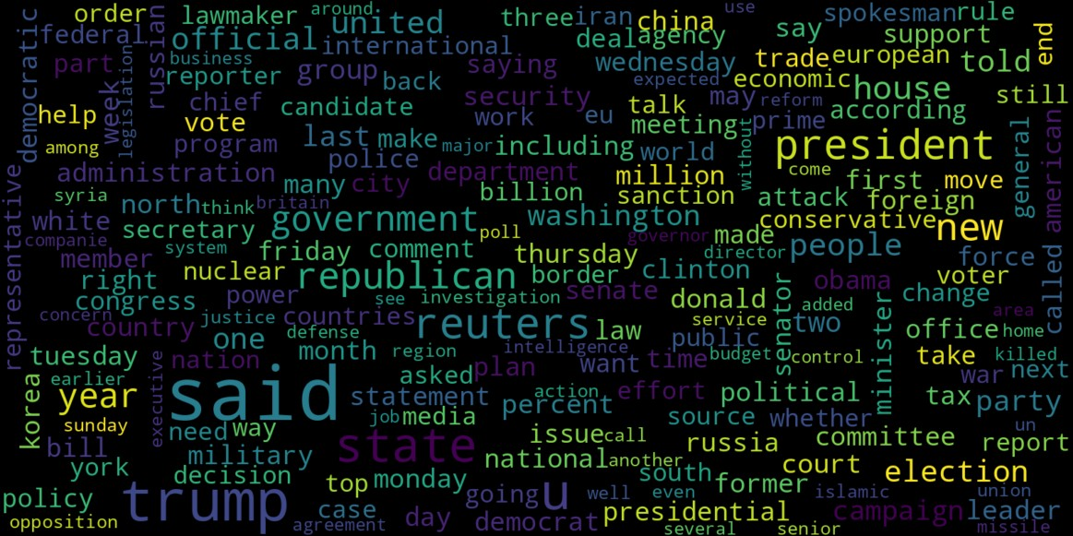

from sklearn.feature_extraction.text import CountVectorizer

def get_top_n_words(corpus, n=None):

vec = CountVectorizer().fit(corpus) bag_of_words = vec.transform(corpus) sum_words = bag_of_words.sum(axis=0)

words_freq = [(word, sum_words[0, idx])

for word, idx in vec.vocabulary_.items()] words_freq = sorted(words_freq, key=lambda x: x[1],

reverse=True) return words_freq[:n]

common_words = get_top_n_words(data['text'], 20)

df1 = pd.DataFrame(common_words, columns=['Review', 'count'])

df1.groupby('Review').sum()['count'].sort_values(ascending=False).plot( kind='bar',

figsize=(10, 6),

xlabel="Top Words", ylabel="Count",

title="Bar Chart of Top Words Frequency"

)

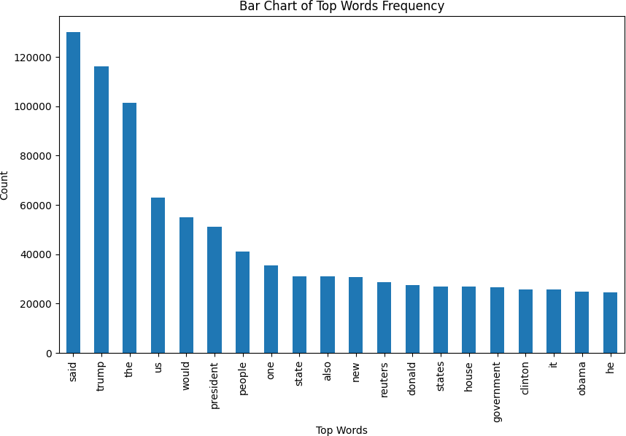<Axes: title={'center': 'Bar Chart of Top Words Frequency'}, xlabel='Top Words', ylabel='Count'>

from sklearn.model_selection import train_test_split from sklearn.metrics import accuracy_score

from sklearn.linear_model import LogisticRegression

x_train, x_test, y_train, y_test = train_test_split(data['text'],

data['class'], test_size=0.25)

from sklearn.feature_extraction.text import TfidfVectorizer vectorization = TfidfVectorizer()

x_train = vectorization.fit_transform(x_train) x_test = vectorization.transform(x_test)

from sklearn.linear_model import LogisticRegression model = LogisticRegression()

model.fit(x_train, y_train)

# testing the model

print(accuracy_score(y_train, model.predict(x_train))) print(accuracy_score(y_test, model.predict(x_test)))

0.9936180949271276

0.9896705253784506

from sklearn.tree import DecisionTreeClassifier

model = DecisionTreeClassifier() model.fit(x_train, y_train)

# testing the model

print(accuracy_score(y_train, model.predict(x_train))) print(accuracy_score(y_test, model.predict(x_test)))

0.9999703167205913

0.9963490650044523

# Confusion matrix of Results from Decision Tree classification from sklearn import metrics

cm = metrics.confusion_matrix(y_test, model.predict(x_test))

cm_display = metrics.ConfusionMatrixDisplay(confusion_matrix=cm,

display_labels=[False, True])

cm_display.plot() plt.show()

